REPORT ON CONSTITUTION DAY CELEBRATION
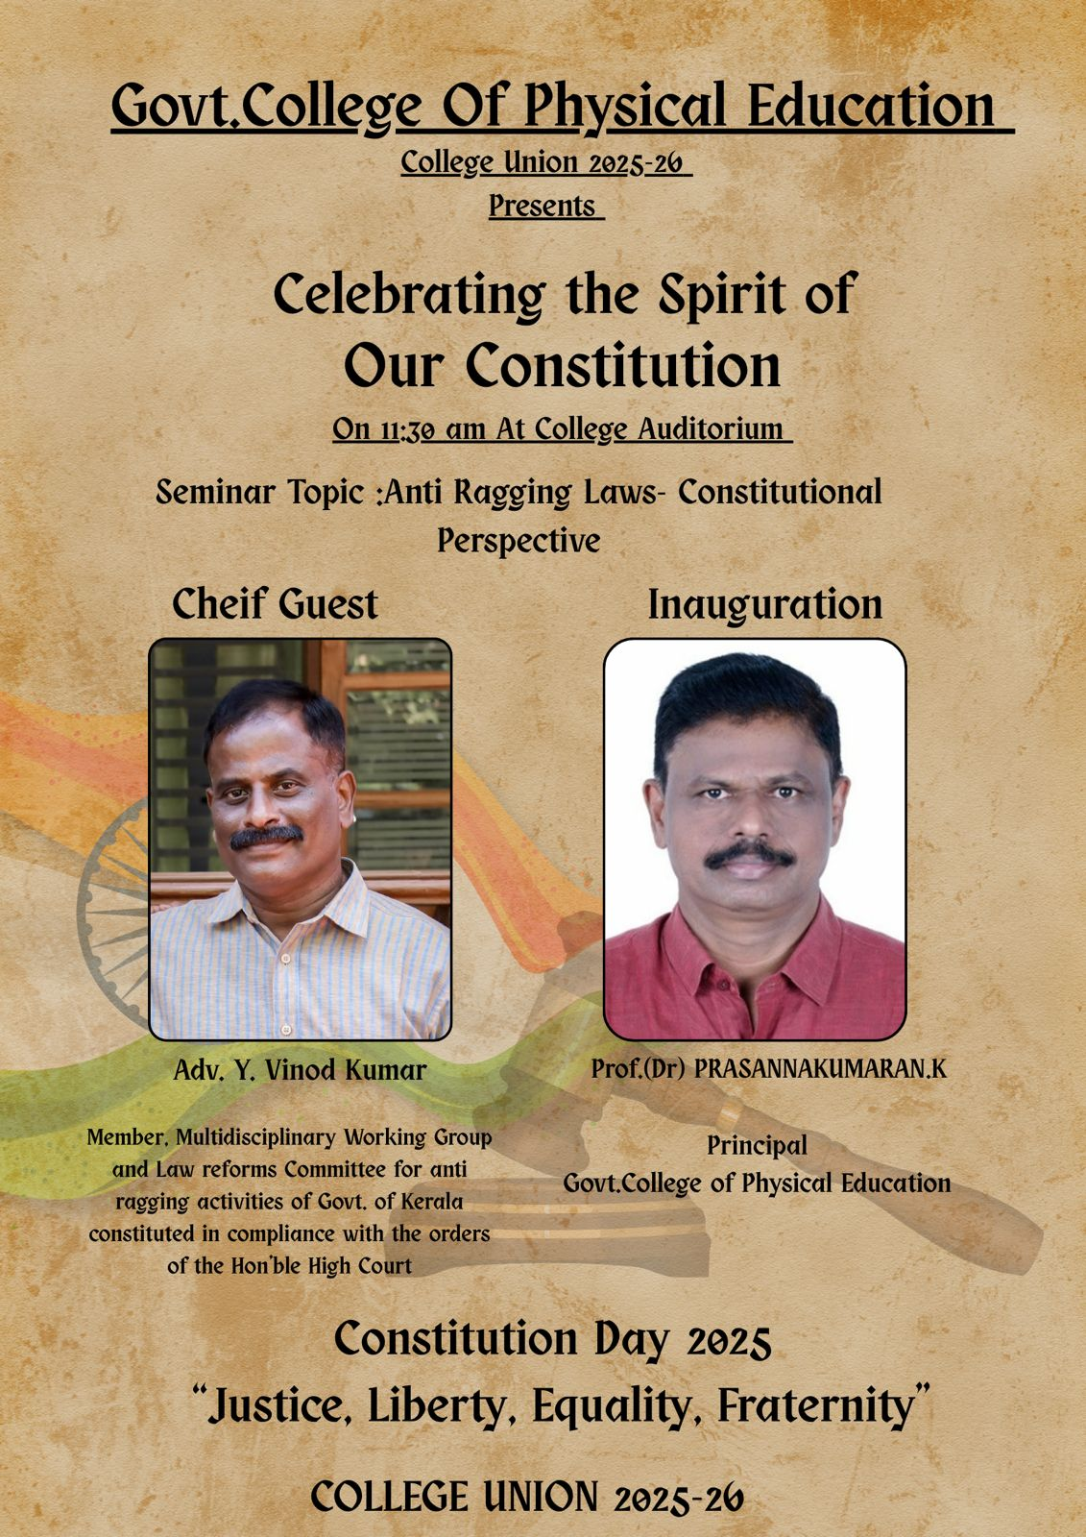
GOVERNMENT COLLEGE OF PHYSICAL EDUCATION, KOZHIKODE
26 NOVEMBER

The Government College of Physical Education, Kozhikode, celebrated Constitution Day on 26 November with great enthusiasm and reverence, commemorating the adoption of the Indian Constitution and honouring its values of justice, liberty, equality, and fraternity.

The programme commenced with a solemn prayer led by Navya K Nair, student teacher, setting a dignified tone for the event. This was followed by a warm and heartfelt welcome speech by Muhammed Rishaan, College Union Chairman, who highlighted the significance of Constitution Day and the responsibilities of citizens in upholding constitutional principles.
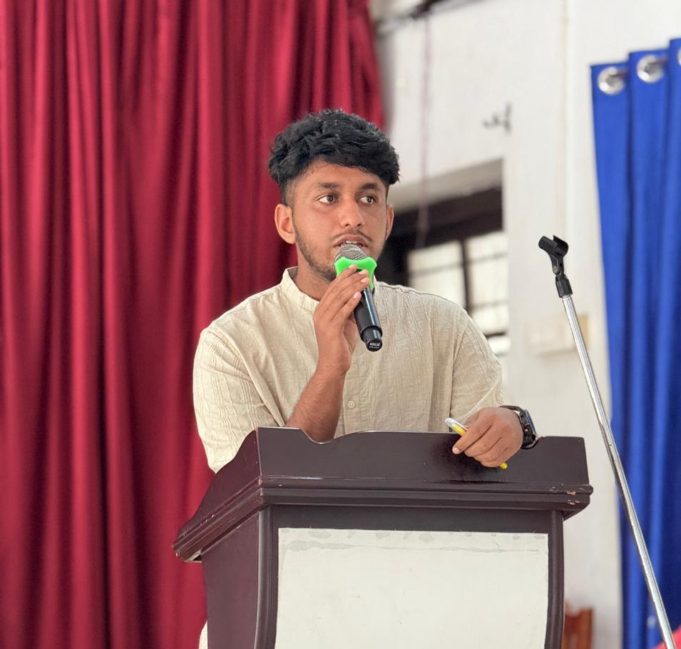

The event was formally inaugurated by Prof. Dr. Prasannakumaran K, Principal, who emphasized the role of education in strengthening democratic values and inspiring students to become responsible members of society. In his address, he underlined the relevance of constitutional ideals in contemporary times.
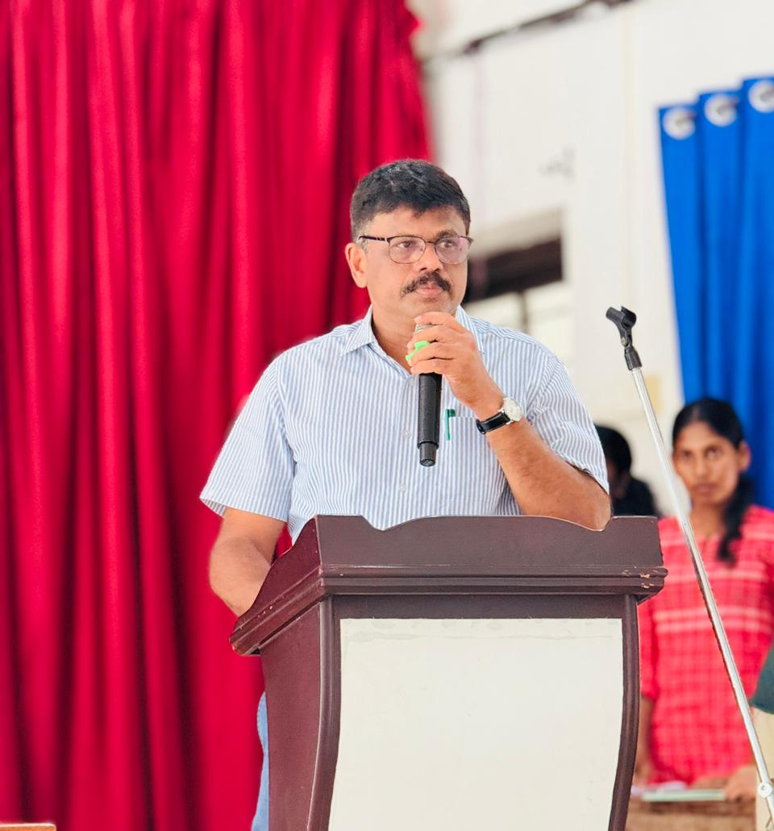

A key highlight of the celebration was the seminar session led by Adv. Y Vinod Kumar, Member, Law Reforms Committee, Government of Kerala. He delivered an insightful talk on the topic “Anti-Ragging Laws – Constitutional Perspective.” His session provided students with a deeper understanding of the constitutional safeguards against ragging, legal consequences, and the importance of creating a safe and inclusive campus environment.

This was followed by a felicitation by Sindhu V.S., Associate Professor, who appreciated the informative session and stressed the importance of awareness programmes in promoting discipline and mutual respect among students.
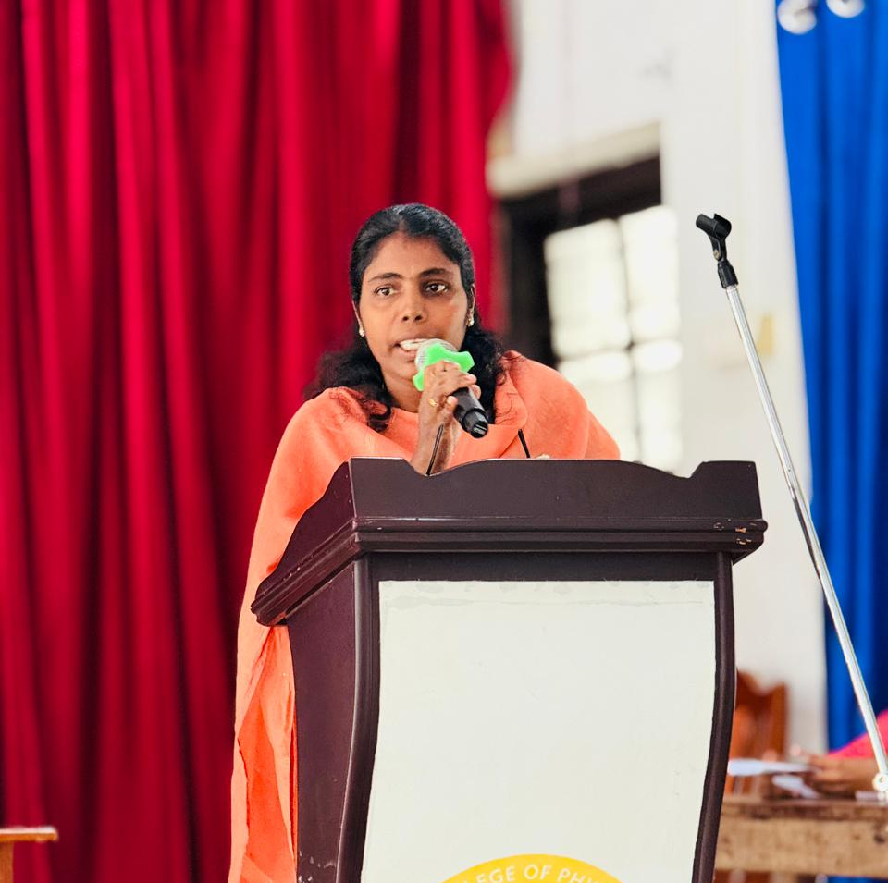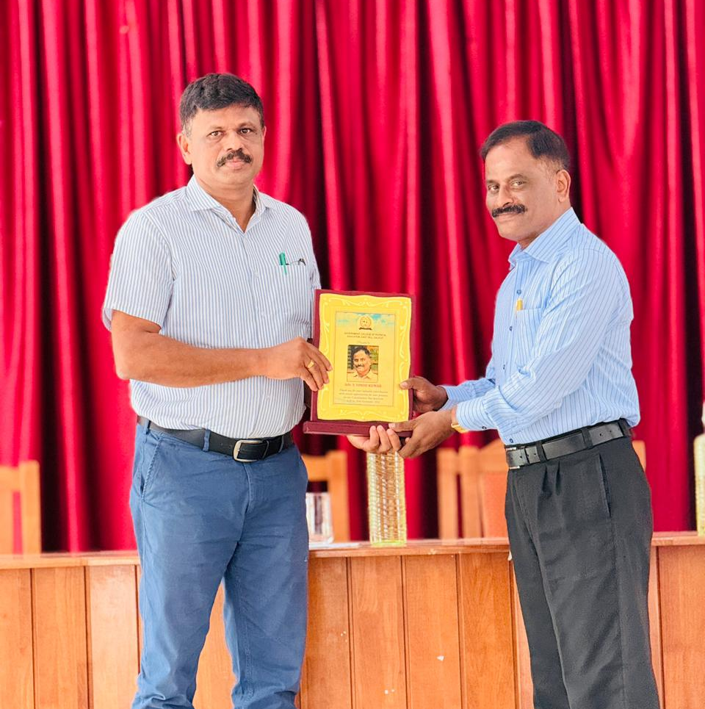

The programme concluded with a sincere vote of thanks proposed by Aswini, Fine Arts Secretary, acknowledging the contributions of the dignitaries, faculty, and students who made the event a success.

The celebration reaffirmed the institution’s commitment to nurturing informed, responsible, and constitutionally aware citizens.

