REPORT OF THE 2-DAY ADVANCED CRICKET COACHING WORKSHOP
Government College of Physical Education, Kozhikode
Earn While You Learn Programme
Dates: 8 & 9 November
Resource Person: Shri. Salim Urambath, BCCI Level–1 Coach

The Government College of Physical Education, Kozhikode, successfully conducted a 2-Day Advanced Cricket Coaching Workshop as part of the Earn While You Learn programme. The workshop was designed exclusively for Government college of physical education student teachers to enhance their capability to teach cricket skills effectively in school and college settings. Sessions were handled by experienced coach Shri. Salim Urambath, BCCI Level 1 Coach, who provided both theoretical insights and practical training
DAY 1 – TEACHING TECHNIQUES & SKILL DEVELOPMENT
Inauguration & Orientation
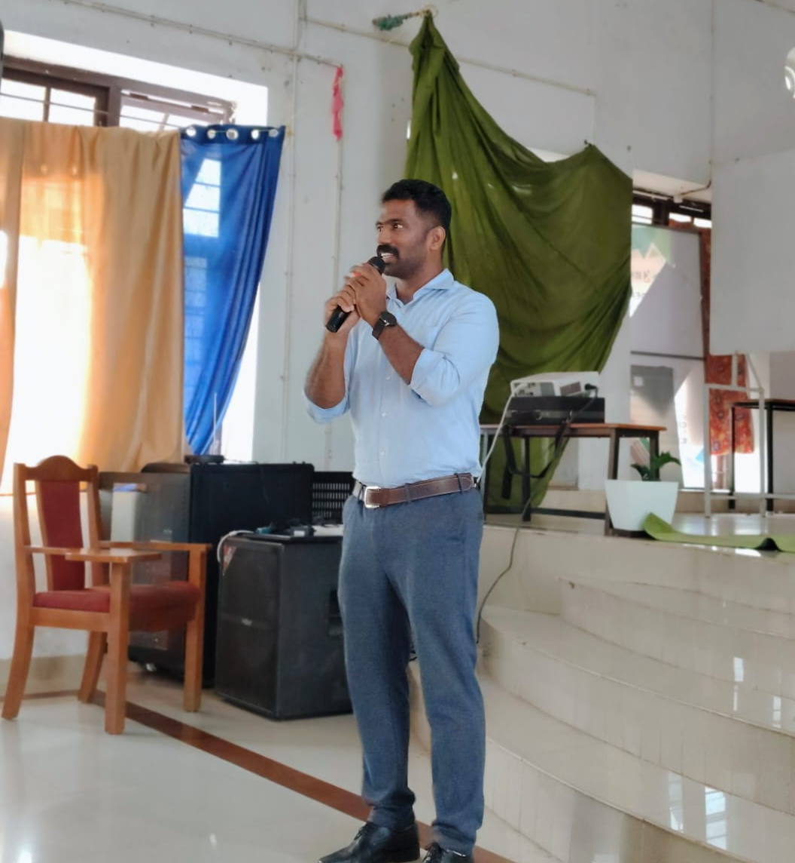
The workshop commenced with a brief inaugural function.
Welcome Address: Mr. Sunil Ramachandran, Assistant Professor, welcomed the participants and highlighted the importance of cricket coaching competency for future physical educators.
Inauguration: Dr. Haris Babu K.S., Assistant Professor, formally inaugurated the workshop. In his address, he emphasized the professional importance of skill-based training and encouraged students to utilise the sessions effectively.
The resource person then provided an overview of the workshop structure and learning objectives.

Session 1: Teaching Batting Skills (10.15–11.45 AM)
Coach Salim introduced effective pedagogical methods for teaching batting.
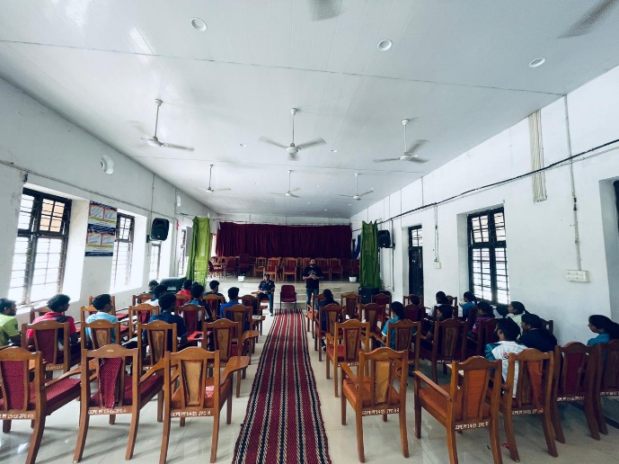
Key components covered:
Demonstration of grip, stance, backlift, and footwork, with emphasis on progressive teaching.
Step-by-step transition from defensive strokes to attacking shots.
Techniques for error detection and correction, especially in novice learners.

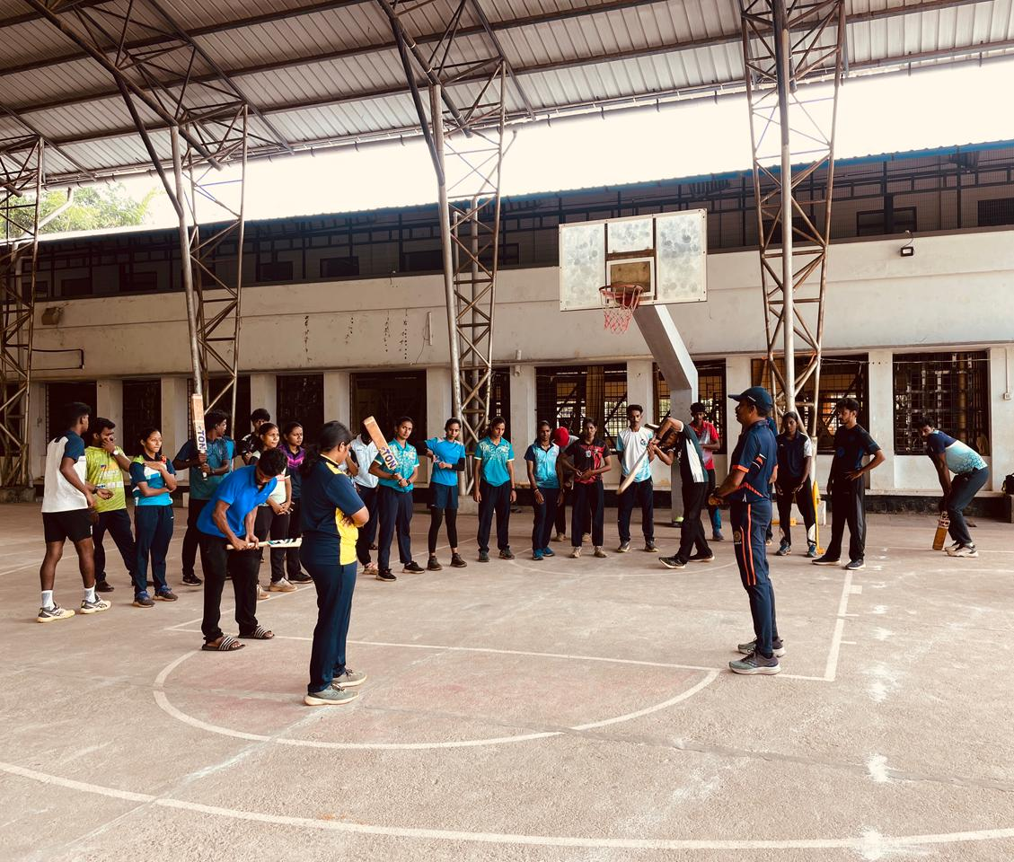
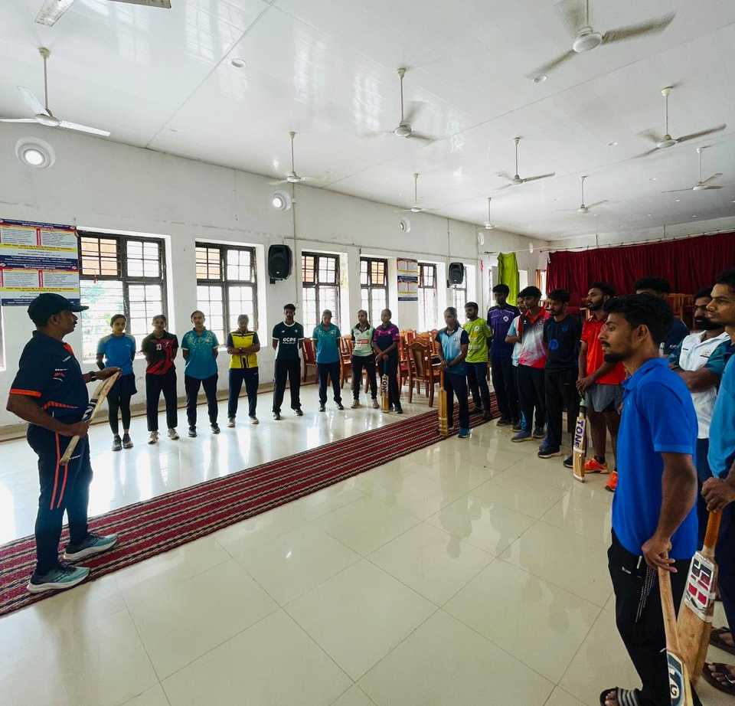
Participants practiced demonstrations and received individual feedback.
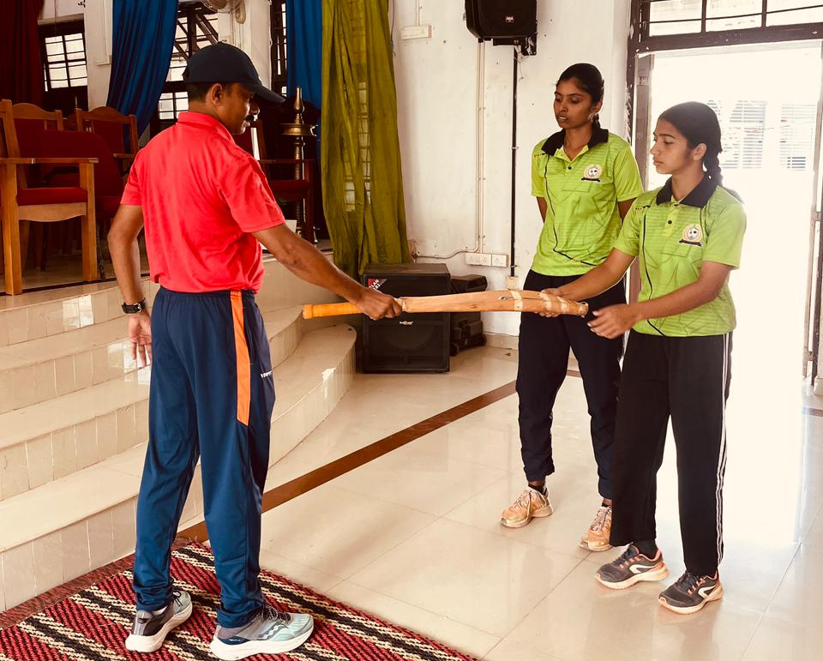
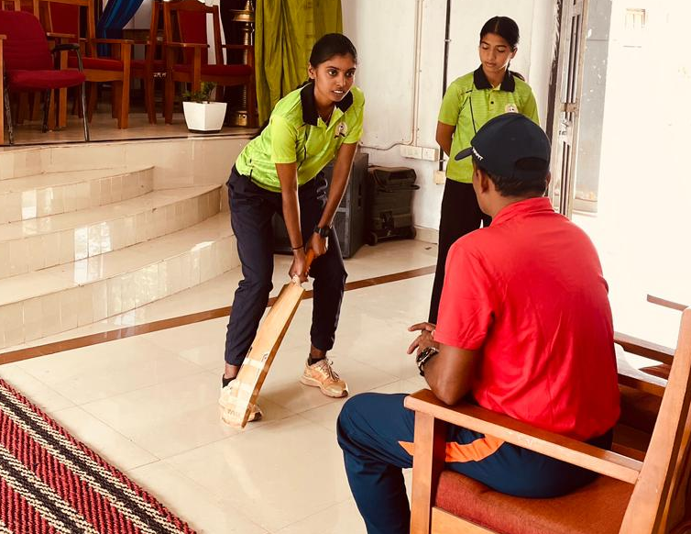

Tea Break (11.45–12.00 PM)
Session 2: Teaching Bowling Skills (12.00–1.30 PM)
This session focused on developing teaching techniques for pace and spin bowling.
Topics included:
- Standard bowling grips, run-up, loading, and release techniques.
- Difference between pace fundamentals and basic spin mechanics.
- Drills to teach line, length, and consistency.
- Safety considerations and prevention of common technical faults.
- Students practiced micro-demonstrations under the guidance of the coach.

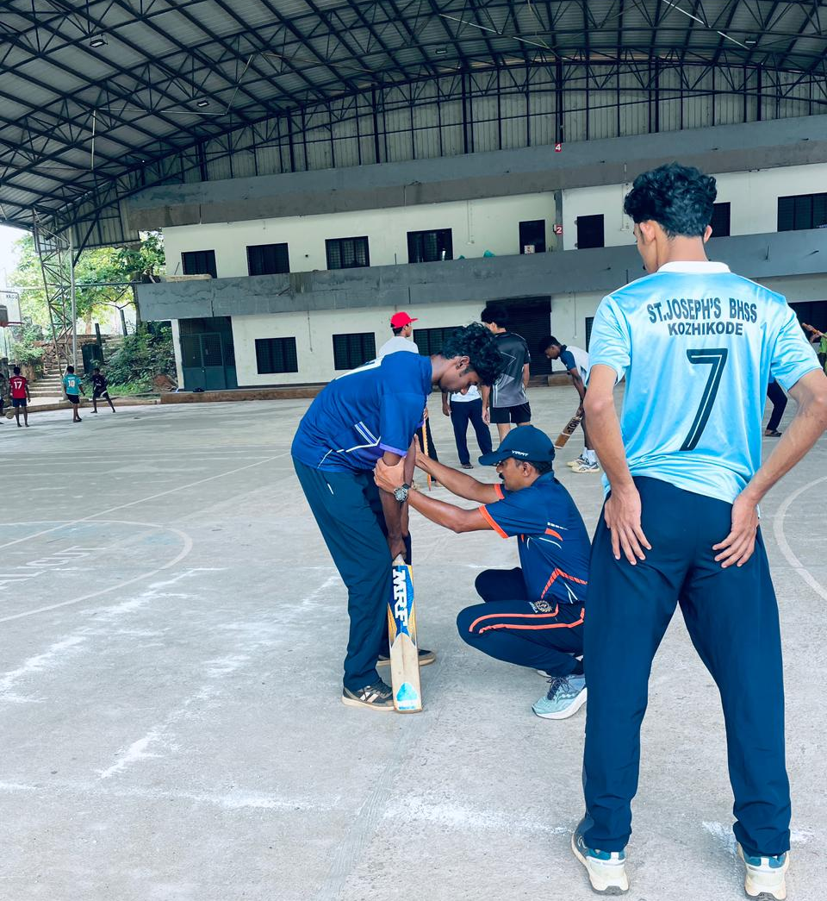
Lunch Break (1.30–2.15 PM)
Session 3: Teaching Fielding Skills (2.15–3.45 PM)
An activity-based session focusing on:
Progressive catching and throwing drills.
Teaching body position, low catching, high catching, and ground-fielding techniques.
Methods to develop anticipation, communication, and teamwork in learners.
Students were grouped and assigned fielding drill setups for practice

Tea Break (3.45–4.00 PM)
Session 4: Cricket-Specific Fitness (4.00–5.00 PM)
Coach Salim demonstrated how to plan safe and effective cricket fitness sessions for school/college settings.
Covered areas:
Proper warm-up techniques.
Agility, speed, and reaction-time drills.
Coordination activities appropriate for learners at different skill levels.
Day 1 concluded with a review of the skills learned.

DAY 2 – TACTICAL UNDERSTANDING & TEACHING PRACTICE
Session 1: Game Strategy & Tactics (10.00–11.30 AM)
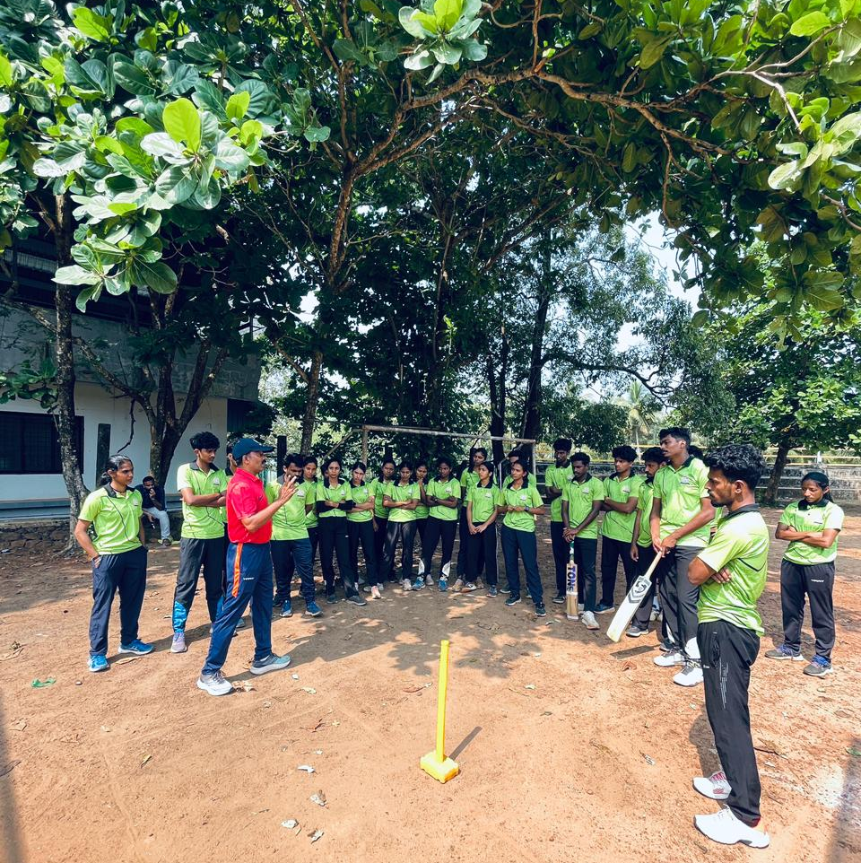
Participants learned how to teach tactical concepts through simple demonstrations and modified games.
Topics included:
Batting plans for different match situations.
Bowling strategies based on field placements.
Using small-sided formats to teach teamwork, communication, and decision-making.
Field setups and tactical boards were used to aid understanding.

Tea Break (11.30–11.45 AM)
Session 2: Match Simulation / TGfU Approach (11.45–1.15 PM)
The resource person implemented the Teaching Games for Understanding (TGfU) approach:
Small-sided matches were organised to enhance tactical awareness.
Students applied concepts under pressure, focusing on real-time decision-making.
The coach highlighted how to use TGfU to make cricket teaching more engaging and meaningful.

Lunch Break (1.15–2.00 PM)
Session 3: Teaching Wicketkeeping & Coordination (2.00–3.30 PM)
This session covered the often overlooked but essential skill of wicketkeeping.
Key areas taught:
Basic stance, glove positioning, and footwork.
Movement and catching drills for both pace and spin scenarios.
Integration of coordination drills to improve hand–eye quickness.
Participants practiced wicketkeeping techniques in small groups.

Tea Break (3.30–3.45 PM)
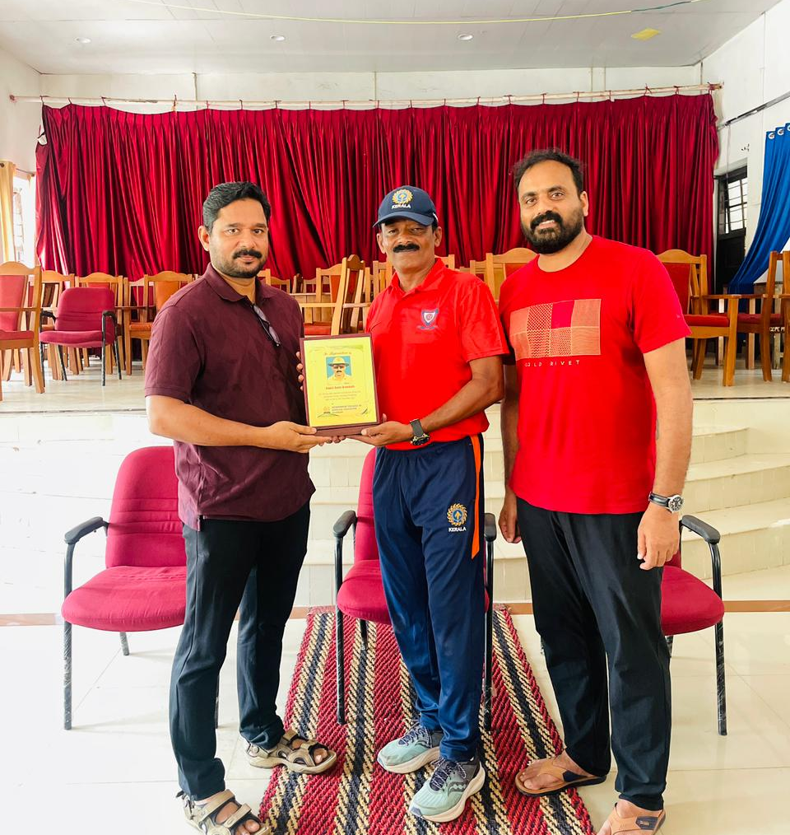
Session 4: Reflection, Micro-Teaching & Closing (3.45–5.00 PM)
Students performed micro-teaching, demonstrating how they would teach cricket skills to schoolchildren.
Coach Salim provided constructive feedback, focusing on clarity of demonstration, error correction, class management, and safety.
Closing Ceremony
The workshop officially concluded with a short valedictory function.
Closing Address: Dr. Sunil Alphonse, Head of the PG Department, appreciated the expert resource person and congratulated the participants for their active engagement.

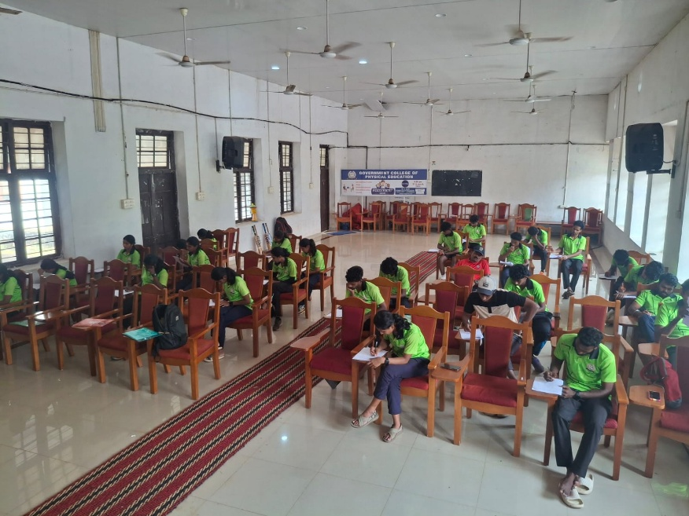
Certificate Distribution: Certificates were distributed to all participants who completed the full 2-day module.
An evaluation exam was conducted at the end of the sessions to assess learning outcomes.

OUTCOME OF THE WORKSHOP
The 2-day Advanced Cricket Coaching Workshop provided college students with:
Strong theoretical and practical understanding of cricket skill teaching.
Competence in planning structured practice sessions.
Ability to identify and correct common technical errors.
Improved knowledge of tactical teaching using modified games.
Enhanced confidence to conduct cricket lessons in real teaching environments.
The workshop was a highly productive experience, strengthening the professional readiness of the students and contributing to the objectives of the Earn While You Learn programme at the Government College of Physical Education, Kozhikode.
