REPORT ON THE SPORTS SEMINAR
“നാവകായിക കേരളം മികവിന്റെ പുതു ട്രാക്കില്‍”
Date: 3rd November 2024
Venue: Rose Lounge Auditorium, Malappuram
Organized by: Department of Sports, Government of Kerala
Time: 9:30 AM – 5:00 PM

1. INTRODUCTION
The one-day sports seminar titled “നാവകായിക കേരളം മികവിന്റെ പുതു ട്രാക്കില്‍” was organized by the Department of Sports, Government of Kerala, as part of Vision 2031. The seminar aimed to envision a comprehensive roadmap for developing Kerala into a premier sporting power in India. It served as a platform for experts, administrators, and sports enthusiasts to share insights on how to build a vibrant sports culture that reaches every section of society.

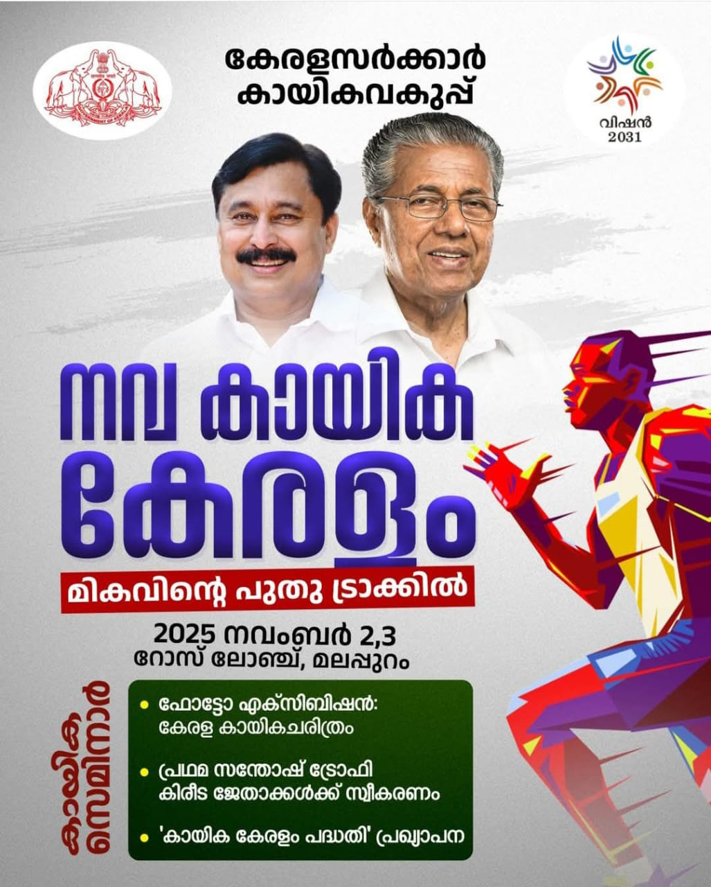
2. AIM OF THE SEMINAR

The main aim of the seminar was to formulate strategies for making Kerala a model sports state by:
*Promoting mass participation in sports.
*Enhancing sporting excellence through scientific and modern methods.
*Developing infrastructure and human resources.
*Integrating sports into education and community life.
*Fostering a sustainable and inclusive sports ecosystem.

3. PARTICIPANTS

Twenty-nine students from the MPEd Second Semester of Government College of Physical Education, East Hill, Kozhikode attended the seminar.The registration process began at 8:00 AM. The seminar witnessed the participation of various dignitaries, sports administrators, academicians, and students from across Kerala.
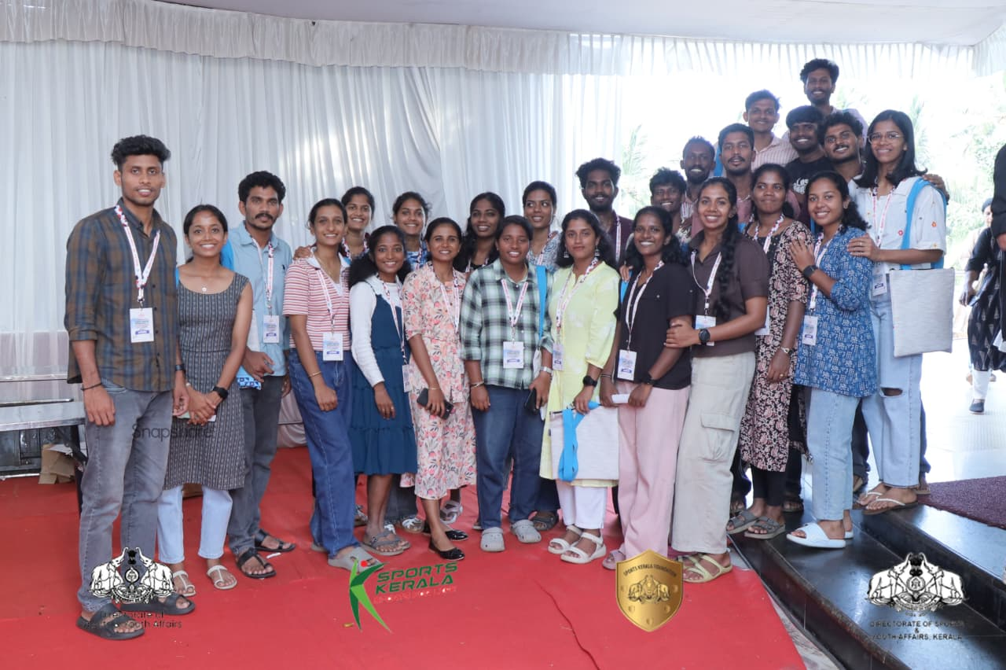

4. PROCEEDINGS OF THE PROGRAMME

*The inaugural session commenced at 9:30 AM.
*Welcome Address: Shri Vishnuraj IAS, Director, Sports and Youth Department.
*Presidential Address: Shri M. Ubaidulla MLA.
*Inauguration: Shri V. Abdul Rahman, Hon’ble Minister for Sports, Government of Kerala.
The Minister officially inaugurated the seminar and announced new initiatives under the Kerala Sports Scheme.
*Presentation on Achievements: Dr. Muhammad Haneesh IAS, Principal Secretary, Sports and Youth Department, presented a detailed report on Kerala’s sports achievements during the past nine years.
*Keynote Address: Shri Santhosh George Kulangara, Member, Kerala State Planning Board, delivered an inspiring talk highlighting the role of planning and innovation in sports development.
*Vote of Thanks: Dr. C. S. Pradeep, Additional Director, Sports and Youth Department.

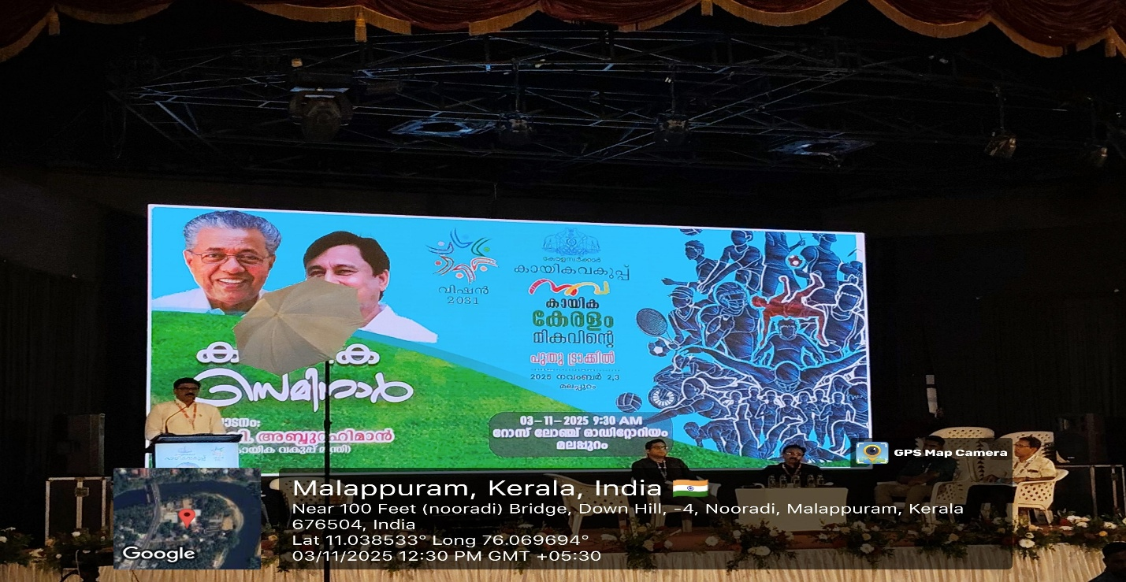

5. SEMINAR SESSIONS AT DIFFERENT VENUES

First Session (12:00 PM – 1:30 PM)
Conducted simultaneously at three venues with diverse themes:
Venue 1: എല്ലാവർക്കും സ്പോർട്‌സ് – അടിസ്ഥാന കായിക വിദ്യാഭ്യാസവും കായികക്ഷമതാ മിഷനും
Venue 2: സ്പോർട്‌സ് സയൻസും മനുഷ്യ വിഭവശേഷി വികസനവും
Venue 3: അടിസ്ഥാനസൗകര്യ വികസനവും കായിക സാങ്കേതിക നവീകരണവും

Each topic was discussed in depth, focusing on foundational sports education, the role of sports science, and infrastructure development.
Second Session (2:00 PM – 3:30 PM)
The afternoon sessions also took place at three venues:
Venue 1: കായിക സമ്പദ്വ്യവസ്ഥ – സ്വയംപര്യാപ്തതയും സുസ്ഥിര വികസനവും
Venue 2: കായിക പ്രതിഭനിർണ്ണയവും ഗ്രാസ്‌റൂട്ട് വികസനവും
Venue 3: സാമൂഹിക ഉൾച്ചേർക്കലും കായികഭരണവും
These sessions emphasized economic self-reliance in sports, grassroots talent identification, and inclusive governance. Each discussion was insightful and encouraged interactive participation from attendees.

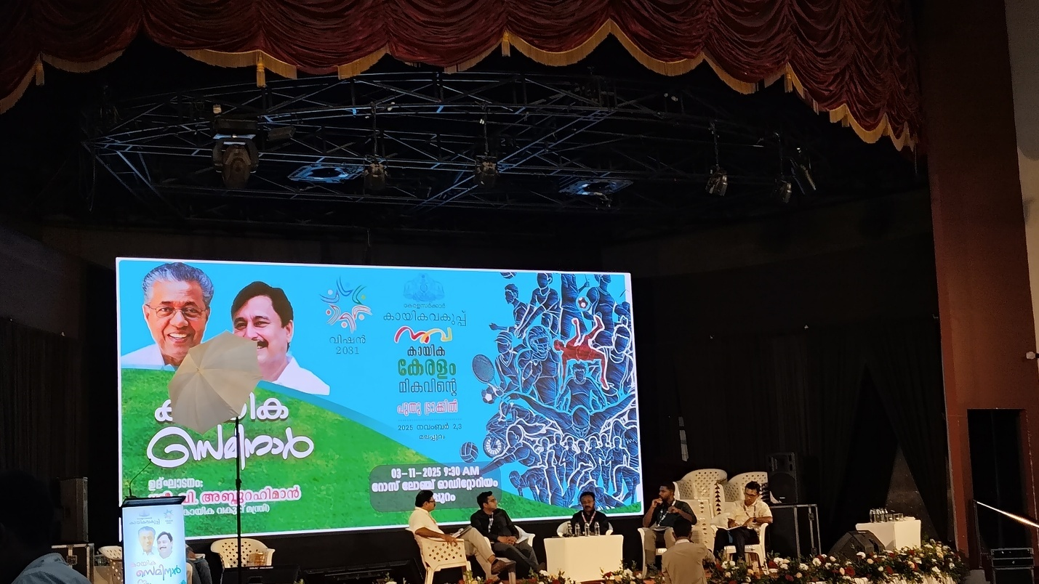

6. PHOTO EXHIBITION
A photo exhibition was organized alongside the seminar, displaying Kerala’s achievements in sports, milestones of eminent athletes, and modern sports infrastructure developments. The exhibition highlighted the state’s rich sporting heritage and inspired participants to contribute towards its bright future.

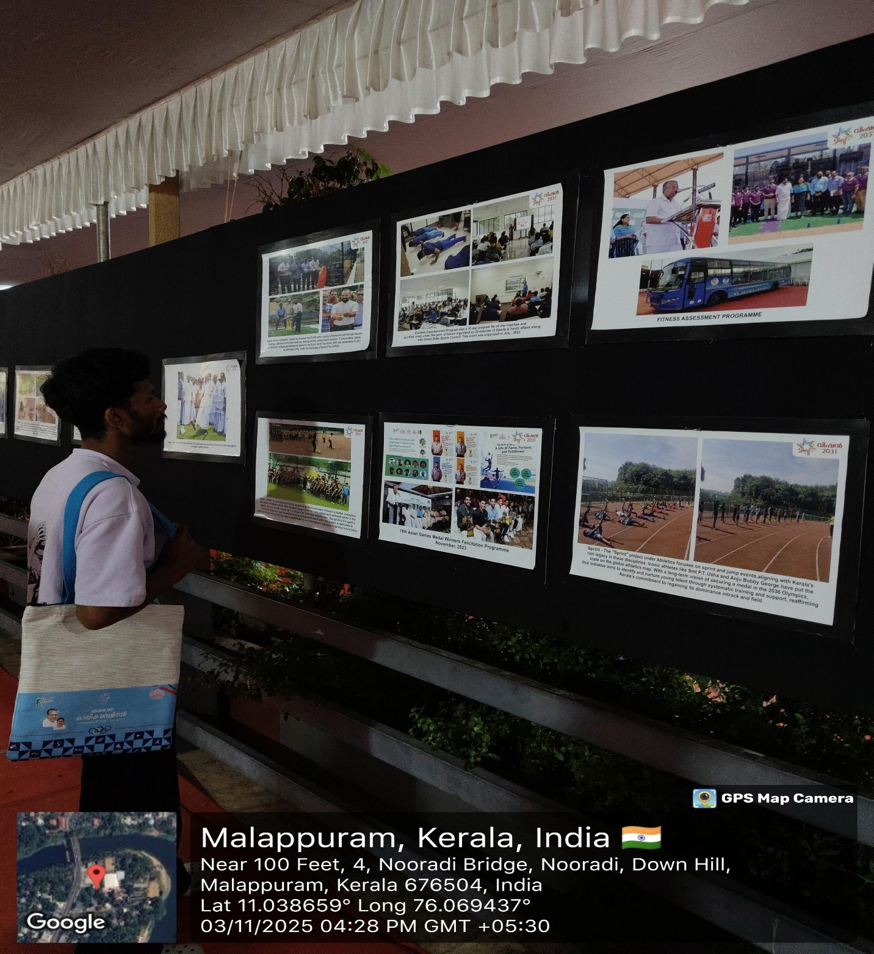

7. CONCLUDING SESSION
The concluding session began at 4:00 PM, led by Dr. G. Kishore, Principal, LNCPE and Regional Director, SAI Trivandrum. He summarized the key takeaways from each session and emphasized the importance of collective effort, innovation, and community involvement in achieving the goals of Vision 2031
8. CONCLUSION
The seminar provided a valuable learning experience for all participants, especially students. It offered a comprehensive understanding of sports development from grassroots to elite levels. The sessions encouraged collaboration among stakeholders to make Kerala a true model of sporting excellence.

SOME RANDOM CLICKS
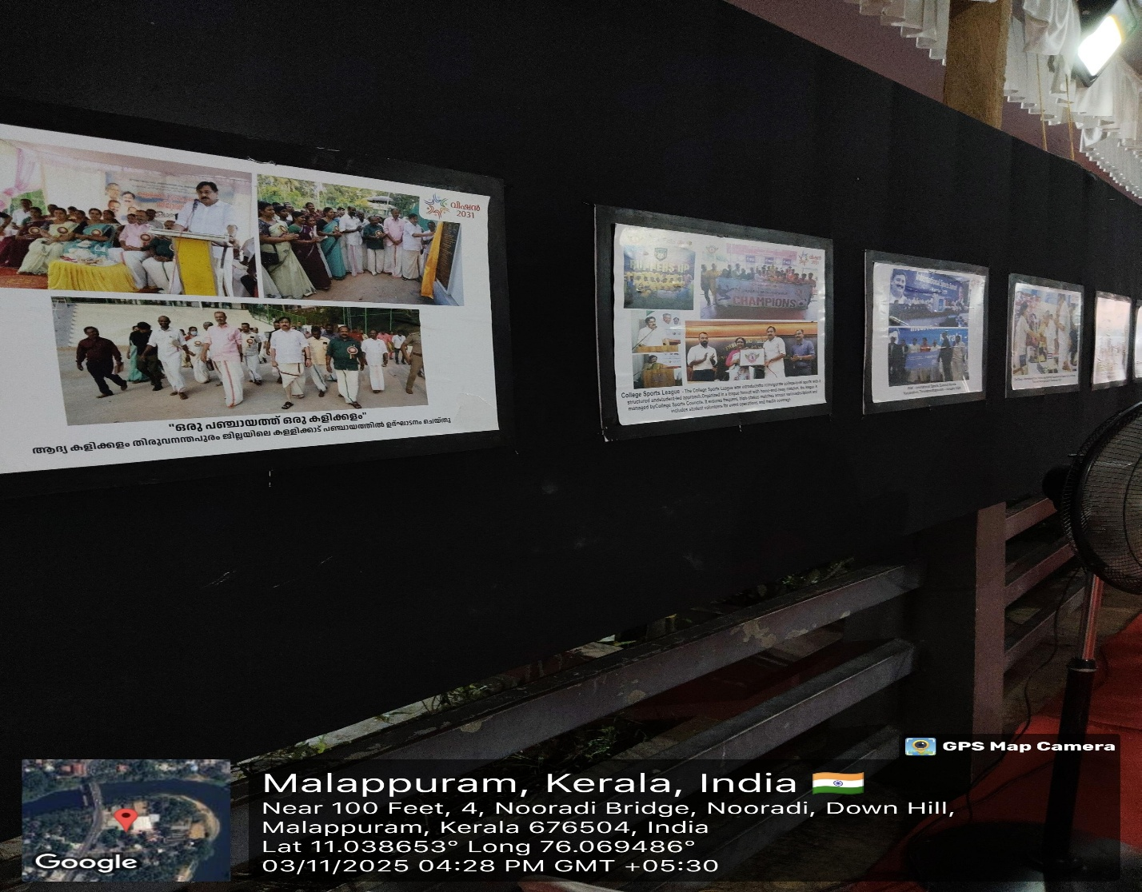
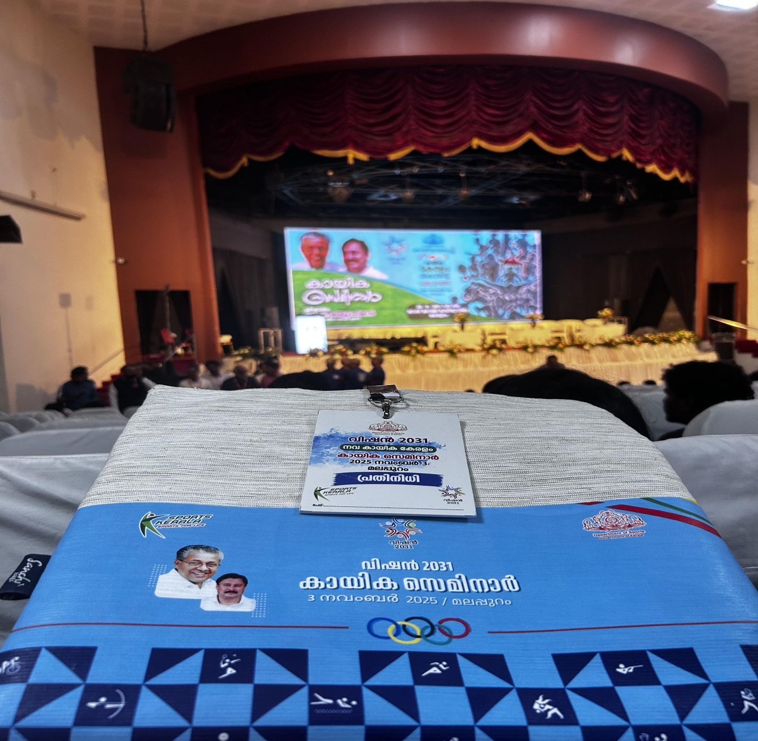

THANK YOU

