**DETAILED REPORT ON DREAMVESTOR 2.0 PROGRAM**

IN ASSOCIATION WITH ASAP CENTRE, GOVERNMENT COLLEGE OF PHYSICAL EDUCATION, EAST HILL, CALICUT**.**

**Introduction**

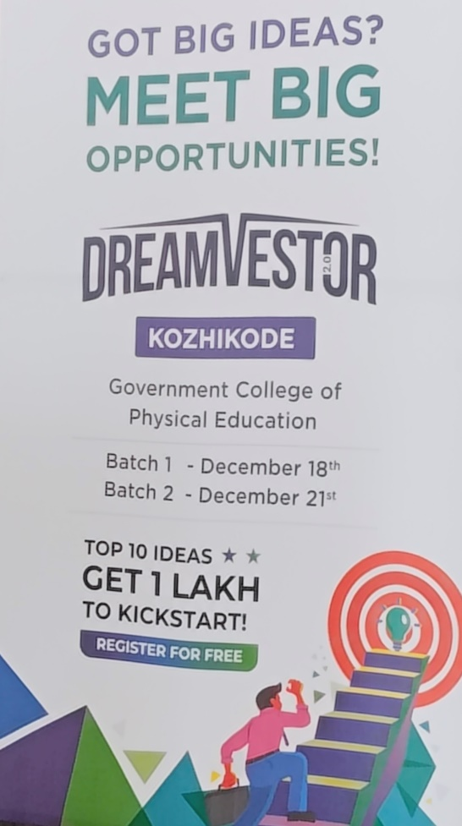The Dreamvestor 2.0 program was conducted on 18th December 2024 at the Government College of Physical Education (GCPE), Kozhikode, in association with the ASAP CENTRE, GCPE, East Hill. The event, held from 9:30 AM to 1:30 PM, aimed to inspire creativity, foster innovation, and promote entrepreneurship among college students. This report outlines the proceedings of the event, its objectives, and its impact on the participants.

**Event Proceedings**

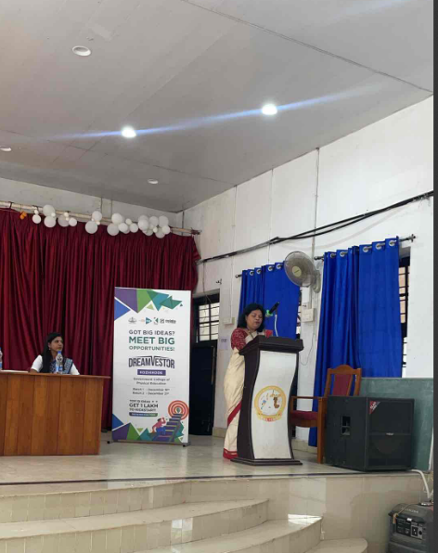The program commenced with a **Welcome Speech** by Ms. Mercy Priya, Associate Director, North Zone, ASAP Kerala. In her speech, she warmly welcomed all the attendees and emphasized the significance of entrepreneurship in shaping the future of students. Her words set a positive and engaging tone for the event.

This was followed by the **Presidential Address** delivered by Dr. Prassanna Kumaran K, Principal of GCPE. Dr. Prassanna Kumaran highlighted the critical role educational institutions play in nurturing entrepreneurial talent. He encouraged students to explore their potential and to view entrepreneurship as a path toward personal and societal growth.

The program was officially **inaugurated** by Shri Renjith Babu, General Manager, District Industries Centre (DIC), Kozhikode. In his inspiring inaugural speech, Shri Renjith Sir elaborated on the role of entrepreneurs in driving economic progress and innovation. He urged students to embrace entrepreneurship as a viable career option and outlined how entrepreneurial ventures contribute to societal advancement.

The **Vote of Thanks** was delivered by Dr. Haris Babu K S, Assistant Professor at GCPE and Coordinator ASAP CENTRE, GCPE, EAST HILL. Dr. Haris Babu k s expressed his heartfelt gratitude to all dignitaries, participants, and organizers for their roles in making the event a success. His acknowledgment of collective efforts underscored the collaborative spirit behind the program.

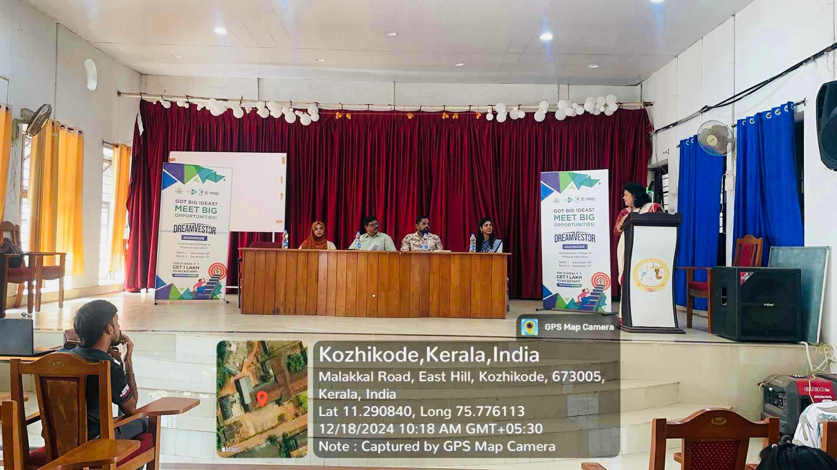

After the formal inauguration, Ms. Anju S Dev, a representative from ASAP Kerala, presented an in-depth overview of the Dreamvestor 2.0 initiative. Her presentation detailed the program's objectives, structure, and potential benefits for participants. She highlighted the program’s focus on creativity, entrepreneurship, and economic growth, sparking enthusiasm among the attendees.

The event featured a **Special Session** by Ms. Luha Saniyya, Co-Founder of All Max’d Talent Base Builders and an accomplished entrepreneur associated with ASAP Kerala. Ms. Saniyya shared her inspiring entrepreneurial journey, recounting the challenges she faced and the skills she developed. Her practical advice and motivational insights resonated deeply with the students, encouraging them to pursue entrepreneurial paths with determination and resilience.

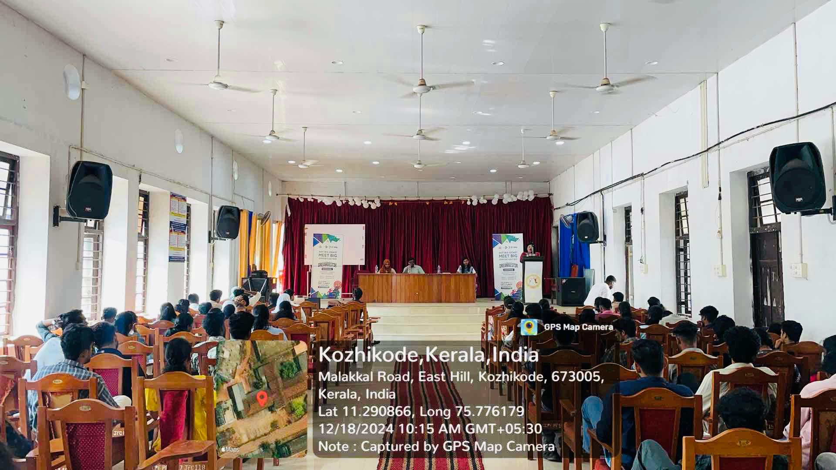

**Key Objectives and Highlights**

The Dreamvestor 2.0 program is structured to achieve the following key objectives:

1. **Foster Creativity and Innovation**: Encourage students to think creatively and develop innovative solutions.
2. **Promote Entrepreneurship**: Inspire students to consider entrepreneurship as a viable career option.
3. **Provide Support**: Offer mentorship and resources to help students transform their ideas into successful ventures.
4. **Contribute to Economic Growth**: Drive economic progress by encouraging new business ideas with societal impact.

One of the major highlights of the event is its **state-wide reach**, with programs conducted across various districts in Kerala. The initiative primarily targets pre-final and final-year college students, providing them with an opportunity to showcase their innovative ideas. The top 10 selected ideas will receive a cash prize of Rs. 1 lakh each, further motivating students to participate and excel.

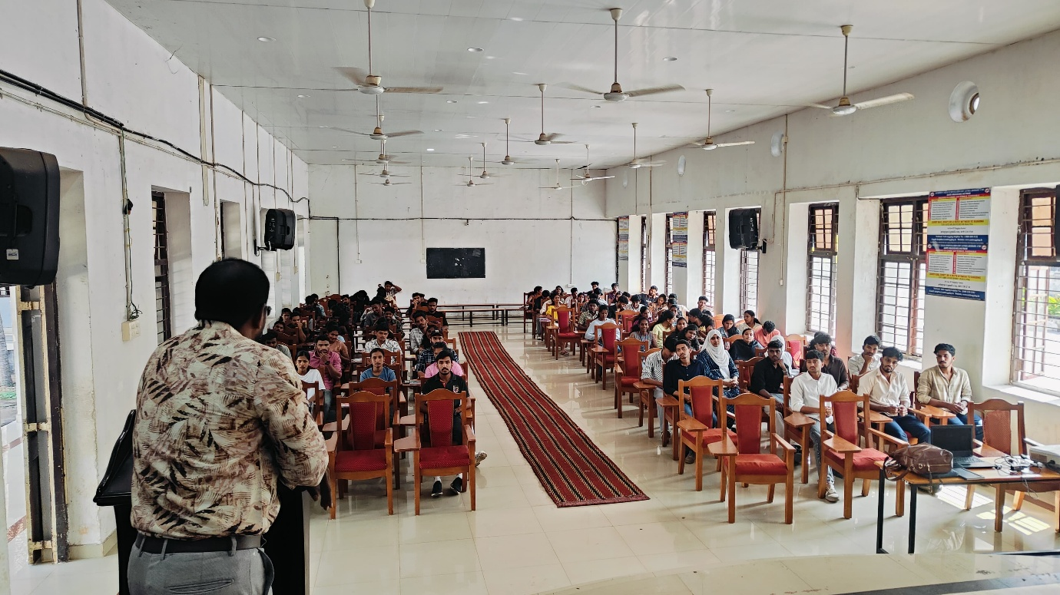

**Program Stages**

The Dreamvestor 2.0 program is implemented through a well-structured series of stages:

1. **Institution Registration**: Institutions are invited to register for participation, ensuring widespread engagement.
2. **Orientation and Team Registration**: Students form teams and receive an orientation about the program’s objectives and processes.
3. **Entrepreneurship Thinking Workshop and Idea Submission**: Workshops help students refine their ideas, which are then submitted for evaluation.
4. **Online Presentation**: Shortlisted ideas are presented online to a panel of evaluators.
5. **Offline Presentation**: Selected teams participate in in-person presentations, allowing for a deeper review of their proposals.
6. **Final Presentation**: The final round involves a comprehensive presentation to a judging panel.
7. **Selection of Winners**: The top 10 ideas are chosen, with each team receiving a cash prize of Rs. 1 lakh.

**Impact of Dreamvestor 2.0**

The Dreamvestor 2.0 program has had a profound impact on students at GCPE, Kozhikode, by:

* Encouraging a culture of innovation and creativity.
* Providing students with practical exposure to entrepreneurial concepts and processes.
* Offering a platform to present their ideas and receive constructive feedback.
* Motivating students to think beyond traditional career paths and explore entrepreneurship as a means of personal and professional growth.

The active participation of dignitaries like Shri Renjith Babu, Dr. Prassanna Kumaran, and Ms. Luha Saniyya elevated the program’s significance. Their speeches and sessions inspired students to view entrepreneurship as an achievable goal.

Student Responses and Benefits

The students responded enthusiastically to the Dreamvestor 2.0 program, with many expressing their appreciation for the insights and opportunities it provided. The interactive sessions, particularly those led by Ms. Anju S Dev and Ms. Luha Saniyya, were described as eye-opening and transformative. Students highlighted how the program helped them:

* Build confidence in presenting their ideas.
* Gain a deeper understanding of the entrepreneurial process, from ideation to execution.
* Network with experts and peers who share a passion for innovation.
* Learn practical skills such as business planning, problem-solving, and effective communication.

Several participants noted that the program inspired them to think beyond conventional career paths and consider entrepreneurship as a viable and exciting option. The hands-on workshops and presentations also enabled students to develop critical thinking skills and explore new ways to approach challenges. Many students remarked that the support and mentorship offered through the program were invaluable in helping them refine their ideas and envision their potential as future entrepreneurs.

The opportunity to compete for a substantial cash prize further motivated students to give their best efforts, fostering a healthy sense of competition and collaboration. The knowledge gained through this initiative will undoubtedly have a lasting impact, empowering students to take bold steps toward achieving their entrepreneurial goals.

The Dreamvestor 2.0 program witnessed enthusiastic participation from students of BPEd final years, MPEd final years, and MPEd first years at GCPE, Kozhikode. Demonstrating remarkable zeal, the students actively registered for the event, aligning themselves with the program's vision to foster creativity, entrepreneurship, and innovation. Several students showcased exceptional ideas, earning selection for upcoming phases of the program. As part of their commitment, the students split into teams and registered for key components of Dreamvestor 2.0, including the Entrepreneurship Development and the State-Level Ideathon, organized jointly by ASAP Kerala and KSIDC. This collaboration provided the students with a unique opportunity to think innovatively and gain exposure to state-level platforms. The program not only enhanced their understanding of entrepreneurship but also inspired them to pursue ventures that contribute to society and the economy. This initiative marked a significant step in empowering future leaders to create transformative solutions.

**Conclusion**

The Dreamvestor 2.0 program at GCPE, Kozhikode, was a resounding success. It not only inspired students to think innovatively but also equipped them with the knowledge and resources to pursue entrepreneurial ventures. By fostering a spirit of creativity and innovation, the program has set the stage for Kerala’s youth to make meaningful contributions to the entrepreneurial ecosystem and the state’s economic development. The event’s comprehensive approach, from workshops to mentorship, ensures that students are well-prepared to embark on their entrepreneurial journeys.

The continued efforts of initiatives like Dreamvestor 2.0 are vital in empowering young minds, creating opportunities, and driving sustainable economic growth. The event at GCPE serves as a testament to the potential of collaborative efforts in shaping a brighter future for students and society at large.